Kennedy Lab

RFLP digest of plant DNA (a.k.a RFLP’ing it up – tree style)

Date:
Hannah Cohen and Molli Bauke 06/2012, after Logan Higgins and Peter Kennedy

Purpose:
Restriction fragment length polymorphisms (RFLPs) use restriction enzymes to cut DNA in specific places (i.e. restriction sites). The resulting fragments are then imaged with gel electrophoresis. Since restriction sites often vary between species, the resulting RFLP pattern can be used to differentiate samples by species. If the RFLP pattern for a species is already known, unknown samples can be matched to the known RFLP pattern for species identification.

Procedure:

Step 1: Deciding which enzyme to use

We have a library of restriction enzymes stored in the -20° freezer. Before you start anything, you should try to figure out which enzyme(s) will be sufficient for your particular task. One way to figure out where any given enzyme will cut is to import the DNA sequence of the organism you are hoping to identify into Sequencher (you can typically obtain the sequences from GenBank). Select the “Cut Map” option in the nucleotide sequence window. This function allows you to choose any combination of well-known restriction enzymes to yield the requisite unique cut pattern for your species of interest.

It can be pretty overwhelming to go through every single enzyme in Sequencher’s database and try to make a decision from there. If you’d like a good idea of where to start, take a look at the restriction enzymes that we already have, located in the box labeled “Reagents and Enzymes” in the -20° freezer. When determining which restriction enzyme that you’d like to use, it’s easiest to use an enzyme that creates one cut site for one species and none for the other, or two cut sites for one species and one site for the other. Additionally, pay attention to the bp lengths of fragments that will be created – you want to make sure that the fragments from each species differ enough in length that they won’t appear too close together on the digest (typically you need at least 25 bp to tell fragments apart).

Step 2: Setting up the reaction

After you’ve chosen your enzyme(s), look it up in the New England Biolabs catalogue online. This page has a lot of information about the enzyme, e.g. the price, the species where the enzyme originally came from, and the actual sequence that the enzyme recognizes and cuts. There are a few bits of information you’ll want to write down. In the top right corner of the page, there should be a bunch of little pictures describing important notes about the restriction enzyme. If you’ll need to use BSA (Bovine Serum Albumin) to stop the enzyme from sticking to the sides of microcentrifuge tubes, there should be a symbol with the letters BSA in the top right. There should also be a symbol that has the correct incubation temperature (usually 37°C) for the enzyme.

Most importantly, on this page you can choose the appropriate buffer number (1-4) in the reactions because the efficiency of the enzymes can vary considerably in the different buffers. Typically, one buffer will be more efficient than the others; choose that one (try to get one with 100% efficiency). In addition to selecting the correct buffer, you also need to calculate how much enzyme to add to your reaction. Enzyme concentrations come in “units,” and these units differ between enzymes. The units of the enzymes in our library are located on the label of the tube they are in. For example, enzyme A may come in 10,000 units/mL, which equals 10 units/μL. For a 15μL reaction, aim to include 2-3 units of enzyme, so in this case, we would add 0.25μL of enzyme A to yield 2.5 units per reaction.

We generally run restriction digests in 15μL reactions in strip-cap tubes. Setting up these reactions is similar to setting up a PCR reaction, only since we’re dealing with high-DNA PCR product, all of this work should take place in the main lab rather than in the clean room. Reactions are set up as follows:

PCR H₂O enough for a total reaction volume of 15μL*
10X digestion buffer 1.5μL
Restriction enzyme 2-3 units (volumes will vary; add this after the buffer)
BSA (if needed) 0.15μL (if not needed then just add more water)
PCR product 8μL (add after you make the master mix)

*If the bands are faint, you can completely take out the water and replace it with all PCR product added. Molli has tried this to get Larix plant DNA to stain more and had only slightly better results than the standard reaction recipe.

To preserve the life of the enzymes when they are out on the bench keep them in a smaller cold block or on ice and add them after the buffer to avoid denaturing them.

Step 3: Placing the reactions in the thermocycler and visualizing results on a gel

Once the reactions are all set up, take the strip-cap tubes to the thermocycler and incubate them at the appropriate temperature for at least three hours, but as long as overnight. We have an RFLP program for you to use, which is set at 37°C. Other programs exist for enzymes that need higher temperatures.

The reactions are visualized on agarose gels. Since RFLP fragments are smaller than typical PCR DNA, it’s best to use a somewhat denser gel (you get better separation of smaller fragments). 2%/1% gels give nice results, but you can also use 1.5%. For a protocol on how to make a 2%/1% gel, use the ‘How to make agarose’ protocol from the Kennedy Microbe Lab website. Pour your gel a bit thicker than a typical gel for PCR visualization, and use wider combs, as you will need space to run the entire 15μL reaction. Load the entire RFLP reaction, and use either the low-range ladder (i.e., 80-1000 bp) or the regular ladder (100-3000 bp). Running a gel for a longer time and distance will typically give the best results, especially when fragments are close in size. Follow regular staining and imagining procedures.

Examples of gels using specific restriction enzymes in species comparisons
RFLP Digest using RsaI on trnL region to compare samples from Alnus rubra and Pseudotsuga menziesii (Hannah Cohen)
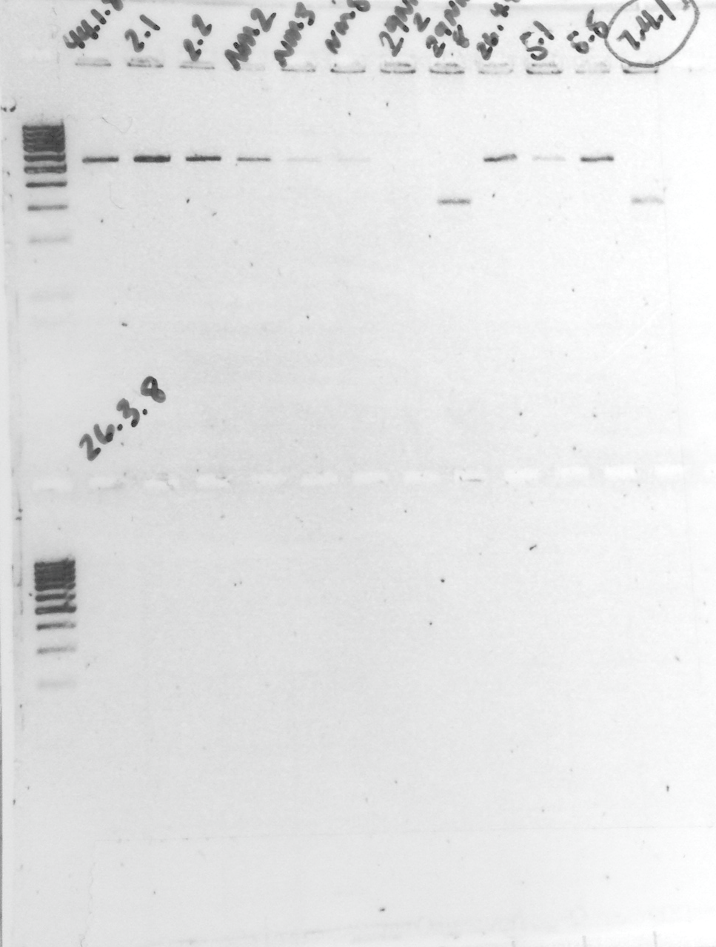

Alnus rubra
Pseudotsuga menziesii

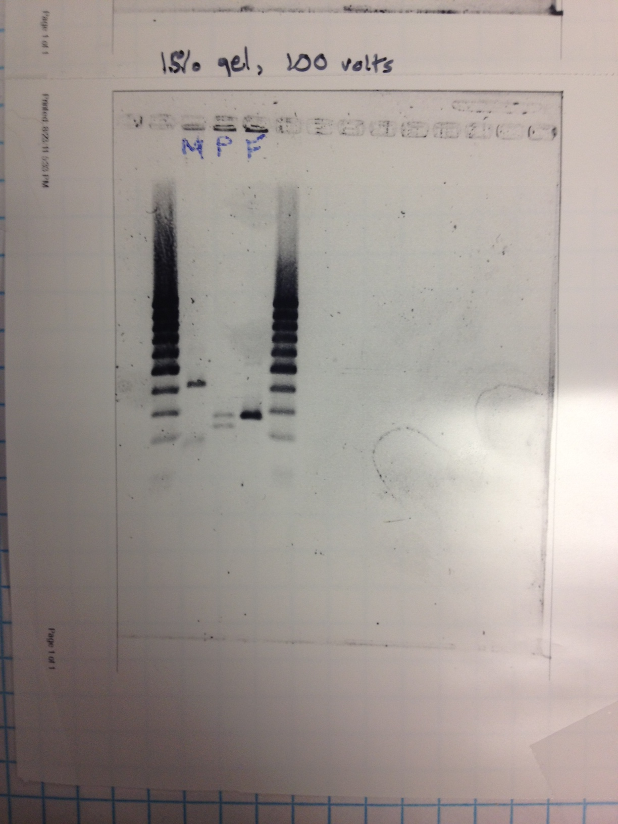
RFLP Digest using DpnII on trnL region to compare samples from Madrone, Pine, and Doug Fir (Dylan Smith)
Pinus ponderosa
Arbutus menziesii
Pseudotsuga menziesii

