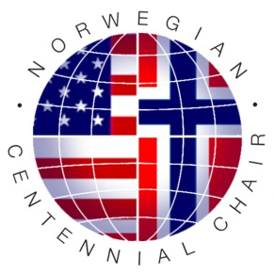

Norwegian Centennial Chair Travel Fellowship Application

Applicant information
Name
Check | Graduate Student Postdoc
Graduate or Postdoctoral Advisor (E-mail address)

University Address
Home Address

Home Phone
Work Phone
E-Mail Address

Which University are you planning to visit, when and for how long?
University: | University of Oslo (UiO)
Norwegian University of Life Sciences (NMBU)
University of Minnesota (UM)
Visit/Travel dates:

Who will be your host for your visit in Norway (UMB, UiO) or Minnesota?
Name
Title/Position
University Address

Work Phone
E-Mail Address

Purpose of visit
- Summarize purpose of visit.
- Explain whether this visit is part of an existing collaboration or represents a new transatlantic collaboration/interaction.
- Describe how this visit will benefit your research and how the collaboration will continue when you return.

Research abstract
Provide a brief summary of your research and planned visit (in layman terms) that can be published in informational materials of the Norwegian Centennial Chair Program. (250 words or less)

Additional Materials

Together with this application form, submit:
1. Short letters of support from your advisor and transatlantic host for your visit
2. Your CV

Submission of application materials

Submit application form and CV electronically to:

Prof. Claudia Schmidt-Dannert

Norwegian Centennial Chair
Dept. Biochemistry
University of Minnesota

E-mail: schmi232@umn.edu
Web: www.nocc.umn.edu

Contact Information:

University of Minnesota

Prof. Claudia Schmidt-Dannert
schmi232@umn.edu

Norwegian University of Life Sciences

Director of Research Dr. Ragnhild Solheim
ragnhild.solheim@nmbu.no

University of Oslo

Office for International Relations Malena Bakkevold
malena.bakkevold@admin.uio.no

