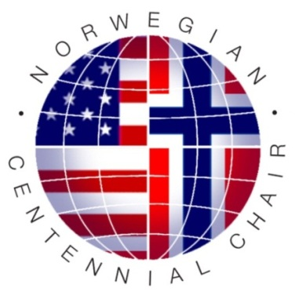**Norwegian Centennial Chair Program**

**Solicitation for Transatlantic Research Proposals**

March 1, 2023

Dear Colleagues,

The Norwegian Centennial Chair (NOCC) Program is announcing a **new request for FY 2023 seed grant** **research proposals**.

The NOCC Program (NOCC: http://cbs.umn.edu/norwegian-centennial-chair/opportunities-research) has been established to support transatlantic collaboration between the University of Minnesota, the Norwegian University of Life Sciences and the University of Oslo. Funding for the program is provided by the three universities to support research in a broad portfolio of topics in science and engineering, and in the health sciences, that are of common, strategic interest to all three partner universities.

This is the fifth round of seed grant proposal requests, following previously funded grants in 2012, 2016, 2018 and in 2020. As in the past, the NOCC program will fund several 2-year project grants of up to $75,000 per year (2nd year funding progress dependent) that will carry out high-quality and impactful transatlantic research projects involving teams from Norway (NMBU, UiO) and Minnesota (UM)(participating units: CBS, CSE, Medical and Veterinary Schools) in strategic priority areas identified by the UiO, NMBU and UM (see below).

A major goal of the project grants is the initiation of innovative and transformative transatlantic research collaborations where the partners from the different institutions each contribute complementary expertise critical to the success of the proposed project. The NOCC program expects that the project grants will be used by the teams to obtain additional funding to continue and expand the transatlantic collaborations.

Research priority areas include:

* Robotics & advanced manufacturing
* Solutions to environmental and climate challenges
* Food safety & security (incl. agriculture, aquaculture)
* Discoveries and treatments for brain conditions
* Sustainable energy systems
* Bio-innnovation and sustainability
* Bio-economy and bio-manufacturing
* Informatics & computation in biomedical research (Big Data)
* Global and One-Health
* Innovation in teaching and learning
* Innovation and entrepreneurship
* Life science for health and innovation

Other areas may also be considered.

Highest priority will be given to **new project teams** that have not previously received NOCC funding and are proposing **high quality research projects** that involve training of **PhD students and postdocs.** Postdoc/PhD student exchange is highly encouraged and postdocs/PhD students who will be supported must be identified by name in the proposal. Specific plans should be described on reciprocal student/postdoc exchange and training. A major part of the budget must be allocated for the support of PhD students and postdocs. Strong research teams involving **junior faculty** are encouraged.

**Seed grant review and selection is competitive,** and it is expected that submitted proposals are of high scientific quality, address a significant problem and provide a detailed research description that clearly describes and justifies roles and collaboration between the transatlantic team members. A proposal submission template is provided on the NOCC web page and must be used. Proposals deemed non-competitive because of low quality, impact or insufficient research description or details on team collaboration etc. may be rejected without receiving a full review to save reviewers’ time.

**Submission deadline for proposals is May 1, 2023**. Projects may start September 15, 2023

If you are interested in developing and participating in a team project, you may contact us for proposal instructions which will also be posted on our NOCC web-site. We will be happy to assist you in the development of a successful, transatlantic research proposal. Also, as our email lists may not be complete, please feel free to forward this solicitation to other colleagues that may potentially be interested in this opportunity.

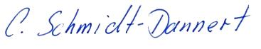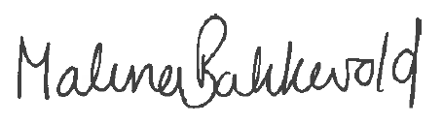Sincerely,

Claudia Schmidt-Dannert Malena Bakkevold Joanna Boddens-Hosang

Norwegian Centennial Chair Co-Chair Acting Co-Chair

University of Minnesota University of Oslo Norwegian University of Life Sciences

[schmi232@umn.edu](mailto:schmi232@umn.edu) [malena.bakkevold@admin.uio.no](mailto:malena.bakkevold@admin.uio.no) [Joanna.boddens-hosang@nmbu.no](mailto:Joanna.boddens-hosang@nmbu.no)